

**MINISTRY OF EDUCATION**

**AND TRAINING**

|  |
| --- |
| Capstone Project Document |
| Mentoring Support System |
|  |
| |  |  | | --- | --- | | **MSS Team** | | | **Group Members** | 1. Trinh Van Tho Loc – SE04905 2. Tran Duc Trung – SE05083 3. Nguyen Xuan Hoang Dung – SE05085 4. Nguyen Tien Dat – SE04909 5. Nguyen Ngoc Thinh – SE04816 | | **Supervisor** | Phan Truong Lam | | **Capstone Project code** | MSS | |
|  |

- Hanoi, 04/2020 –

Table of Contents

1 CHAPTER 1: INTRODUCTION 4

1.1 Purpose 4

1.2 Project information 4

1.3 The people 4

1.3.1 Supervisor 4

*1.3.2* Team members 4

1.4 Problem 5

1.5 Existing system 5

1.5.1 V.Edu 5

1.5.2 Faceworks 6

1.5.3 VINN 7

1.6 The proposal of system 7

1.6.1 Out of scope function 7

2 CHAPTER 2: PROJECT MANAGER PLAN 8

2.1 Problem Definition 8

2.1.1 Name of this CapStone Project 8

2.1.2 Problem Abstract 8

2.1.3 Project Overview 9

2.2 Project Organization 11

2.2.1 Software Process Model 11

2.2.2 Roles and Responsibilities 12

2.2.3 Tool and Techniques 15

2.3 Project management plan 15

2.3.1 Task 15

2.3.2 Task sheet: Assignments and Timetable 16

2.3.3 All Meeting Minutes 16

2.4 Convention Rules 17

2.4.1 Front-end Coding Convention 17

2.4.2 Back-end Coding Convention 18

2.4.3 Database Naming Convention 18

2.4.4 Document Convention 19

2.5 Risk Management Plan 19

2.5.1 Risk description 19

2.5.2 Probability - Impact matrix 21

2.5.3 Definition 21

# CHAPTER 1: INTRODUCTION

## Purpose

This chapter provides an overview of the Mentoring support system. The purpose of this system is to manage all online students of FPT University on the Coursera system. This will reduce manual work in managing online students, helping teachers and mentors work more quickly and effectively.

## Project information

Project name: Mentoring support system

Project code: MSS

Project group name: MSS Team

Product type: Website application

Timeline: From 6 th January

## The people

### Supervisor

|  |  |  |  |
| --- | --- | --- | --- |
|  | Full name | E-Mail | Title |
| Supervisor | Phan Trường Lâm | lampt2@fe.edu.vn | Lecturer |

*Table 1-1: Supervisor's information*

### Team members

|  |  |  |  |  |
| --- | --- | --- | --- | --- |
|  | Full name | Student code | E-mail | Role in Group |
| 1 | Trinh Van Tho Loc | SE04905 | Loctvtse04905@fpt.edu.vn | Leader |
| 2 | Tran Duc Trung | SE05083 | Trungtdse05083@fpt.edu.vn | Member |
| 3 | Nguyen Xuan Hoang Dung | SE05085 | Dungnxhse05085@fpt.edu.vn | Member |
| 4 | Nguyen Tien Dat | SE04909 | Datntse04909@fpt.edu.vn | Member |
| 5 | Nguyen Ngoc Thinh | SE04816 | Thinhnnse04816@fpt.edu.vn | Member |

*Table 1-2: Team member’s information*

## Problem

Nowadays, in the "4.0 - modern life", many studies show that: in comparison with traditional learning, online learning helps people to save about 50-70% money, and it is considered a modern, economical and effective learning solution. In online learning, it is extremely important to manage and monitor the learning progress of students. Thus, it requires an easy management and monitoring system for mentors. According to some online learning systems such as FUNIX, hocmai.vn, these systems only help mentors interact with students by answering questions about daily subjects but don't support them to manage and follow the learning progress of each student. For this reason, mentors will be lost the necessary control with their students. In online learning, students have to have a really high self-discipline and initiative, and it is not easy. Therefore, in order to take effect online learning for students, mentors need to have a support system that manages and monitoring students. In the Coursera system, the daily statistics about students' learning situation in a day will be sent for mentors, so that, the mentor can manage the learning time and subject process of the students in their class. But the data will be sent as excel.csv files, so it will be difficult to read and analyze the data because of the large amount of information and the sense of the interface. Therefore, it is necessary to design support software for mentors, which is convenient, smart, and easier to use.

## Existing system

### V.Edu

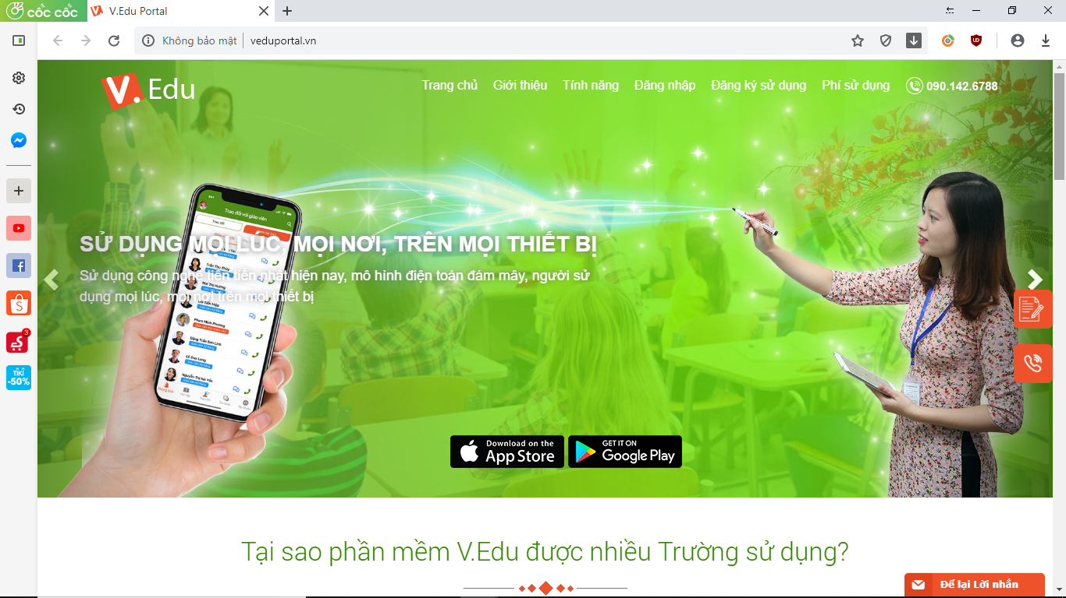

*Table 1-3: Existing system: V.Edu*

The system allows staff and teachers to update students' training information on computers and tablets (iPad). It also allows people to import student lists, tuition lists, transcripts, and comment sheets from excel file into them ezWork: Online Education Management System

- Development company: Orient Sofware JointStock Company (Công ty Cổ phần Phần mềm Phương Đông).

- Customer: Primary, Secondary, High School, Intermediate, College, University, Education system, Education center, etc.

- How to use: monthly payment

### Faceworks

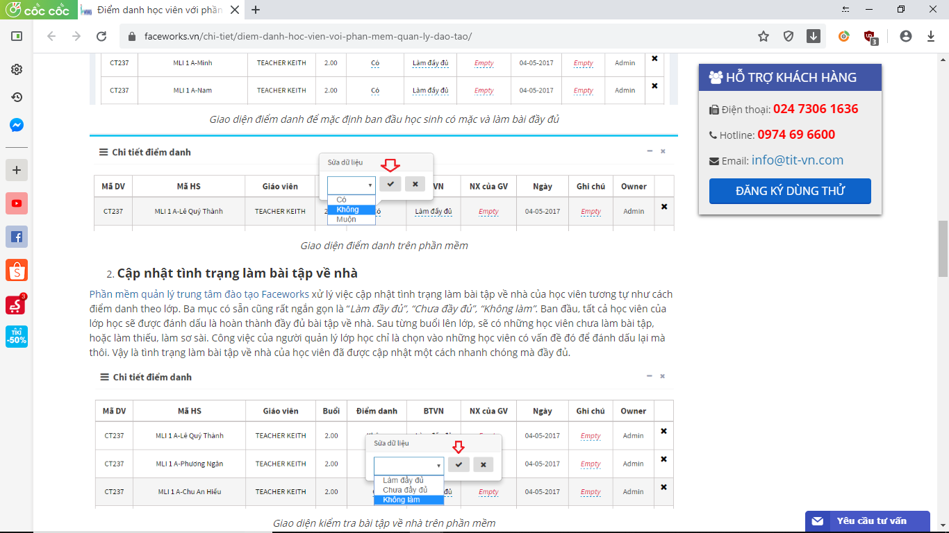

*Table 1-4: Existing system: Faceworks*

* Faceworks: Training Center Management System
* Development company: Công ty Cổ phần Dịch vụ và Công nghệ TIT
* Customer: Education centers…
* How to use: monthly payment

### VINN

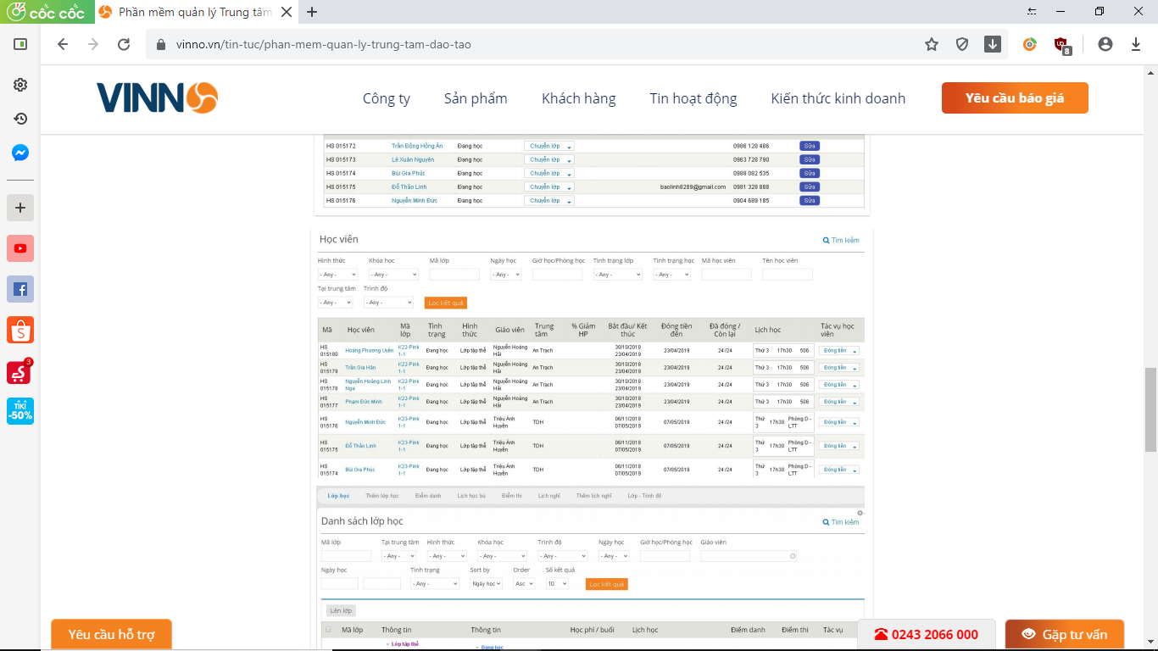

*Table 1-5: Existing system: VINN*

* VINN: Student Management System
* Development company: Công ty Vinno Việt Nam
* Customer: Magic Music – Nhạc Viện Hà Nội, Minh Quang Company,…
* How to use: monthly payment

## The proposal of system

Building MSS website application to manage FPT University's online students on Coursera system with the following main functions:

- Import Coursera report files to the system

- Define subject, course, specialization

- Make reports to help mentors understand the status of students. Warn students who study less than 5 hours /week

- Manage students studying online on the Coursera system of FPT University at all campus

- Students can submit certification after completing the course

### Out of scope function

Because of the time limitation, we will not implement these following functions:

* Students cannot view their progress on the system
* To increase the performance and as required by the supervisor, we didn't design a great interface.

# CHAPTER 2: PROJECT MANAGER PLAN

## Problem Definition

### Name of this CapStone Project

The official name for the project is Mentoring Support System (MSS)

### Problem Abstract

Currently, FPT University has four campuses in Hoa Lac, Da Nang, Can Tho and Ho Chi Minh City with nearly 2000 students taking online courses on Coursera. With the continuous development of the school, the number of students will increase. Since then, the number of students studying online and online subjects will grow continuously, creating a burden for the university in managing students. With the current traditional method, each mentor must manage hundreds of students by excel. Every day, they must supervise students attending the course to warn students who do not meet the quota, manage the students' submission of the course certificate, etc. Example: A mentor manages 100 students on A total of 2000 students took the online course. To understand the learning situation of the students they manage, they must manually review, filter out 100 students under their management of a total of 2000 students. Then send an email to students who have not completed the target of the number of hours per week, etc. From there, mistakes, omissions of students, and waste of human resources will occur when the number of students studying online is increasing day by day. To reduce the burden of student management, we need new supporting software. So our team developed a new software called Mentoring support system.

### Project Overview

#### The Current System

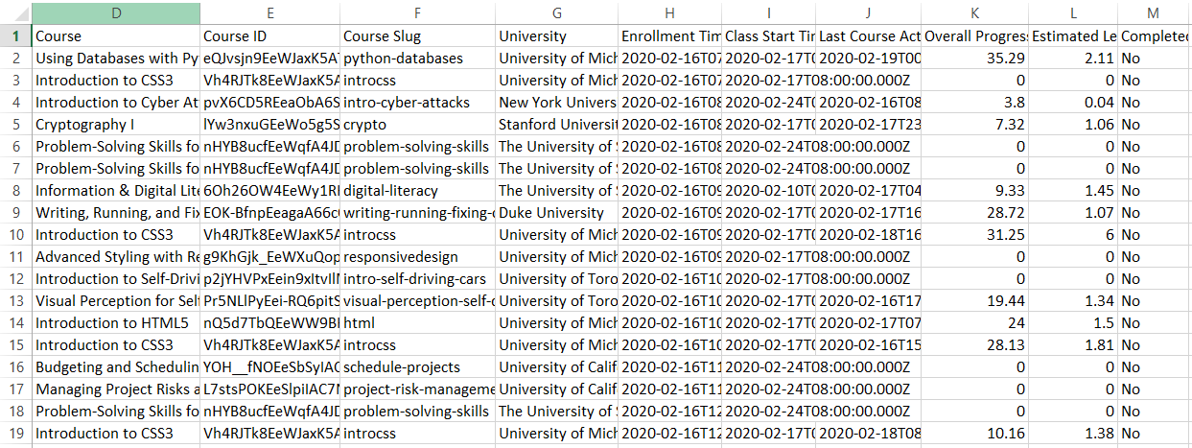Currently, FPT University uses the Excel tool to manage students studying online.

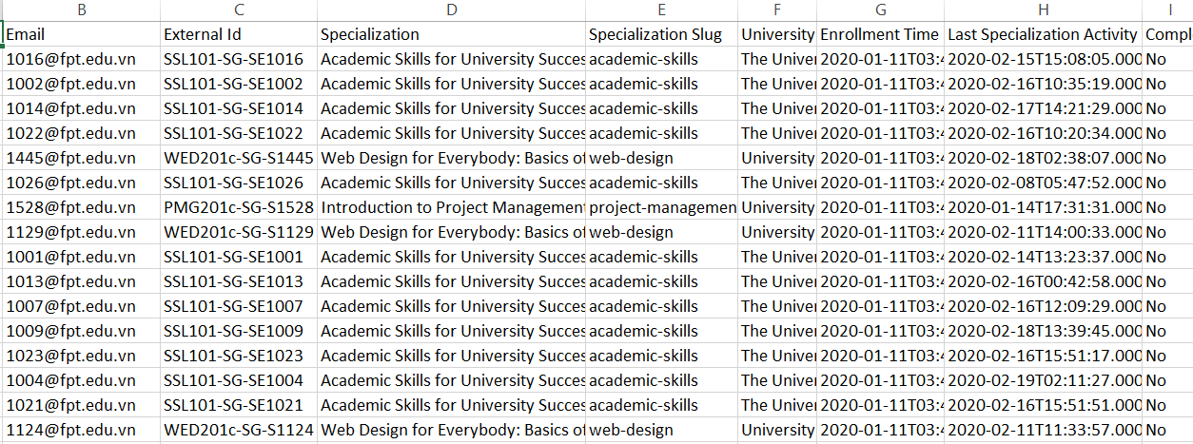Figure 2-1: Using Excel to manage students studying online (file usage-report)

Figure 2-2: Using Excel to manage students studying online (file specialization-report)

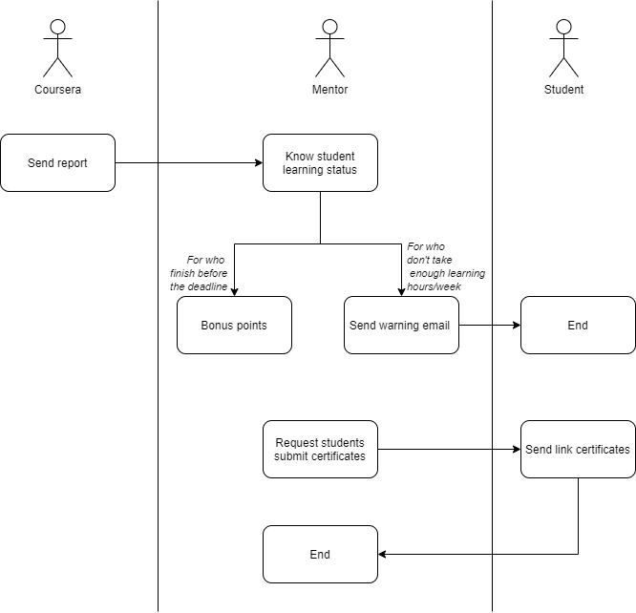

Figure 2-3: Current system

#### The Proposed System

Mentoring support system is a web application with the following main functions:

* Manage user
* View report daily
* Import file csv, excel
* Manage certificate of student
* Manage campus
* Manage subject, course, specialization

#### Boundaries of the System

In the scope of this project, MSS includes:

* A web application with details description in Chapter 3.
* Software project documents.

#### Development Environment

Dev tools:

- Microsoft Visual Studio 2015 community

- Microsoft SQL Server 2012

Hosting:

- Window Server 2019

- Microsoft SQL server 2008 R2

## Project Organization

### Software Process Model

In the MSS project, we used the Waterfall Process model.

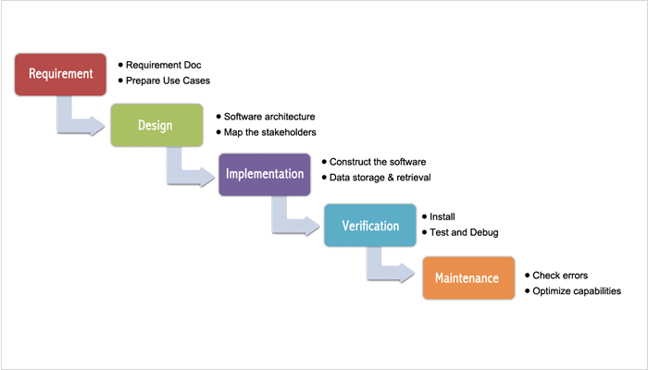

Figure 2-4: Waterfall Software Process model

* The project has not changed much in scope.
* Project requirements are well understood and fixed.
* Simple model, the team member is familiar with this model.
* Customers know exactly what they want.

### Roles and Responsibilities

#### Team Organization Structure

|  |  |
| --- | --- |
| **Role** | **Responsibilities** |
| Project Manager | Planning, developing schedules, coordinating communication, generally responsible for keeping the team’s focus on the main goal. |
| Technical Leader | Responsible for choosing and deciding what technologies should be used, as well as for overseeing the work being done by other developers. |
| Quality Assurance Manager | Ensuring the product meets the certain standards of quality from requirements. |
| Test Leader | Responsible for test execution, including test set-up and test run, evaluation of test run and error recovery, defect logging and test results recording. |
| Developer | Involve in coding the product and reviewing code of other developers. |
| Designer | Involve in designing the product’s user interface. |
| Tester | Involve in testing the product. |

Table 2-1: Project Structure

#### Project Team Member

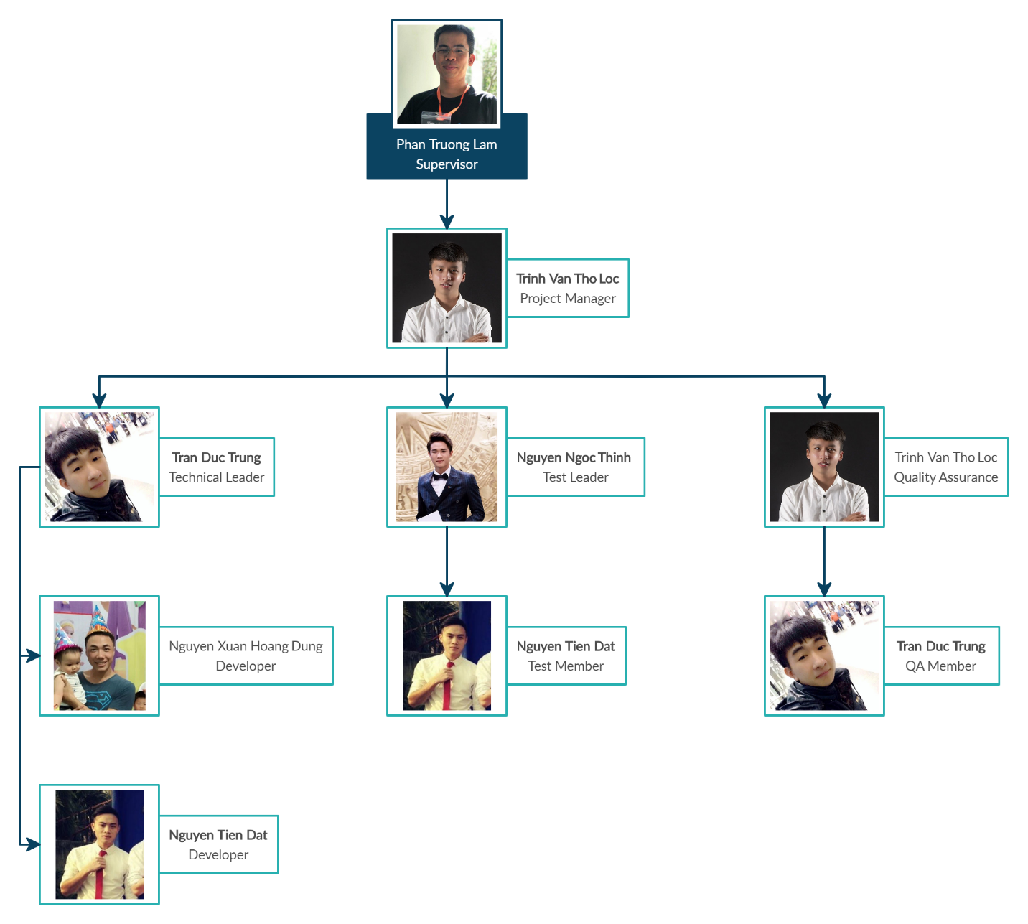

Figure 2-5: Project Team Member

|  |  |  |
| --- | --- | --- |
| **Full Name** | **Role** | **Responsibility** |
| Phan Truong Lam | Supervisor | * Give instruction for project team * Supervise project team’s status |
| Trinh Van Tho Loc | Project Manager | * Develop and design detailed project plans * Arrange meetings and assign task to team members * Manage project implementation schedule in accordance with test plan * Take care for teammates, review documents * Provide status reports to the supervisor * Be the final approval of the design specification * Design database |
| **Development Team** | | |
| Tran Duc Trung | Technical Leader | * Review the code of the members and quickly find errors if any. * Track development of the quality of work and skills of developers * Update, learn new technology to suggest for developers to learn and apply in the project. |
| Nguyen Xuan Hoang Dung | Developer #1 | * Coding & Unit test. * Planning and management of all his work and progress reports. |
| Nguyen Tien Dat | Developer #2 | * Coding & Unit test. * Planning and management of all his work and progress reports. |
| Tran Duc Trung | Designer | * Study Bootstrap * Design and implement website |
| **Test Team** | | |
| Nguyen Ngoc Thinh | Test leader | * Create test plan, test cases, test report * Execute test |
| Nguyen Tien Dat | Tester #1 | * Support for testing |
| **QA Team** | | |
| Trinh Van Tho Loc | Document leader | * Learn related parties * Prepare documents * Note meeting |
| Tran Duc Trung | Documentation | * Learn the real business |

Table 2-2: Role and Responsibility

### Tool and Techniques

These are the tools and infrastructure the project team will use to develop the system

|  |  |
| --- | --- |
| **Category** | **Tools & techniques** |
| Programming languages & runtime | C#, HTML5, JavaScript |
| Frameworks | Bootstrap, ASP.NET MVC, Entity Framework, JQuery |
| Software architecture | MVC |
| Operating system | Windows |
| Version control | GitHub, Git 2.24.0.2 |
| IDE/Editors | WebStorm 2019.3, Visual Studio Code 1.40.2 |
| UML tools | Astah Professional 8.0, Draw.io, Creately.com |
| DBMS | Microsoft SQL Server |
| Project management tools | Microsoft Project 2016 |
| Document tools | Microsoft Office 2013 |
| Process model | Iterative and Incremental Software Process Model |
| Communication tools | Facebook, Skype |
| Files management tools | Google Drive |
| Testing tools | Selenium webdriver |

Table 2-3: Tools

## Project management plan

### Task

|  |  |  |  |  |
| --- | --- | --- | --- | --- |
| **Task** | **Description** | **Output** | **Resource needed** | **Responsible** |
| Project initial | Receive handover source code | Project charter | 9 days | LocTVT |
| Create project plan | Create project plan for this Capstone Project | Project Plan | 7 days | LocTVT |
| Create SRS | Create Software Requirements | SRS | 7 days | LocTVT |
| Create SDD | Create Software Design Description | Architecture design, GUI Design, diagrams | 12 days | TrungTD, DungNXH |
| Import database | Database standardization for go-live |  | 7 days | TrungTD |
| Create test plan | Create system test cases following SRS | Test case | 7 days | ThinhNN |
| Coding | Implement source code for the application to cover the requirements | Source code | 21 days | TrungTD, DungNXH, DatNT |
| Unit test | Executing Unit Test | Unit test report | 1 day | DungNXH, DatNT |
| Integration test | Executing Integration Test | Integration test report | 5 days | ThinhNN |
| System Test | Executing System Test | System test report | 1 day | ThinhNN |
| Project close | Deploy the system | Close meeting | 1 day | TrungTD, DungNXH, DatNT, LocTVT, ThinhNN |

Table 2-4: Task list

### Task sheet: Assignments and Timetable

### All Meeting Minutes

All meeting minutes will be written following this template:

|  |  |  |  |  |  |
| --- | --- | --- | --- | --- | --- |
| ***Meeting/Project Name:*** | ***Mentoring Support System*** | | | | |
| ***Date of Meeting:*** | *20/02/2020* | | ***Time: (Type)*** | *2 hours (Online)* | |
| ***Meeting Called by:*** | *TrungTD* | | ***Location:*** | [*meet.google.com*](http://meet.google.com/) | |
| ***Note Taker:*** | *LocTVT* | | ***Time Keeper:*** | *DungNXH* | |
| **1. Meeting Objective** | | | | | |
| * To receive the database from the supervisor | | | | | |
| **2. Attendance** | | | | | |
| ***Name*** | ***Roles*** | ***E-mail*** | | | ***Phone*** |
| Trinh Van Tho Loc | Project Manager | [LocTVTSE04905@fpt.edu.vn](mailto:LocTVTSE04905@fpt.edu.vn) | | | 0962745197 |
| Tran Duc Trung | Developer | [TrungTDSE05083@fpt.edu.vn](mailto:TrungTDSE05083@fpt.edu.vn) | | | 0978306897 |
| Nguyen Ngoc Thinh | Tester | [ThinhNNSE04816@fpt.edu.vn](mailto:ThinhNNSE04816@fpt.edu.vn) | | | 0971986813 |
| Nguyen Tien Dat | Developer | [DatNTSE04909@fpt.edu.vn](mailto:DatNTSE04909@fpt.edu.vn) | | | 0912364346 |
| Nguyen Xuan Hoang Dung | Developer | [DungNXHSE05085@fpt.edu.vn](mailto:DungNXHSE05085@fpt.edu.vn) | | | 0374015295 |
| **3. Tasks Done** | | | | | |
| * Design GUI * Create Homepage * Design database | | | | | |
| **4. To-Do Tasks** | | | | | |
| * Pull database on project * Create Test Plan | | | | | |
| **5. Difficulty** | | | | | |
| * Because of the epidemic situation, the group had to make online meeting by meet.google.com. Our group encountered some difficulties in exchanging information | | | | | |

Table 2.5 – Meeting minute template

## Convention Rules

### Front-end Coding Convention

**Folder naming:**

● Written in “PascalCase”, for example: “MyReport”

**File naming:**

● Written in “PascalCase”, for example: “CardArticle.cshtml”.

**JavaScript Style Guide:**

● We strictly follow JavaScript Standard Style Guide, with linter and automatic code fixer. Please refer to the official website at <https://standardjs.com/rules.html>.

### Back-end Coding Convention

**Folder naming:**

* Written in “PascalCase”, for example: “MyReport”

**File naming:**

* Written in “PascalCase”, for example: “CardArticle.cshtml”.

**JavaScript Style Guide:**

* We strictly follow JavaScript Standard Style Guide, with linter and automatic code fixer. Please refer to the official website at <https://standardjs.com/rules.html>.

**Folders/files naming:**

* Written in “PascalCase”. Example: “InviteRequest”, “CreateInviteRequest.cs”, “FollowOrganization.cs”.

**.Net Style Guide:**

* We strictly follow Coding Style Guide of Microsoft. Please refer to the official website at <https://docs.microsoft.com/en-us/dotnet/csharp/programming-guide/inside-a-program/coding-conventions>

### Database Naming Convention

**Tables naming:**

* Names should be written uppercase the first letter and after the "_", with underscore (“_”) between words. Example: “Specialization_Log”, “Course_Log”.
* Tables should have their names written in singular form.

**Columns naming:**

* Names should be written uppercase the first letter and after the "_", with underscore (“_”) between words. Example: “Specialization_Slug”, “Enrollment_Time”.
* Primary key fields should be named id. Example:

CREATE TABLE Specialization_Slug (

id INTEGER PRIMARY KEY NOT NULL,

title CHARACTER VARYING(255) NOT NULL);

### Document Convention

* Font family: Arial.
* Font size: 12 pt.
* Quoted text : "quote"
* Project name: Mentoring Support System
* Notes : This is note

## Risk Management Plan

The project manager works with the project team and guarantees that risks are actively identified, analyzed, and controlled throughout the life of the project. Risks will be identified as early as possible in the project so as to minimize their impact. The steps for achieving this are described in the following sections. The project manager will serve as the Risk Manager for this project.

### Risk description

|  |  |  |  |  |  |  |  |
| --- | --- | --- | --- | --- | --- | --- | --- |
| **No** | **Risk** | **Description** | **Category** | **Root Cause** | **Contingency Plan** | **Probability** | **Impact** |
| R1 | Member leaves the project | Member leaves the project | Human | Members want to move to another project team or leave off work | Recruit new member | Low | High |
| R2 | Conflicts among member | Not define  clear tasks  and unify the  opinion  before  starting tasks | Human | Team  member  disagree  with others  and refuse to  work or work  below their  ability | Project manager have to resolve that problem, make a meeting or voting to unify opinions | Medium | High |
| R3 | Absence/illness of team member | Team members are sick, busy that can not complete task | Human | Personal reasons | Share the task of absent member | Medium | Medium |
| R4 | Late deadline | Team members don't complete the deadline | Human | Team member not hardworking, don’t follow the deadline | Member must report everyday, every step to PM. So PM can control the project’s process | Medium | Medium |
| R5 | Lost data during operation | Error occurred causing loss data | Process | Equipment is broken, server is down | Backup data every day/week | Low | Medium |
| R6 | Lack of skill | Member is  lack of  knowledge  and skill to  complete a  particular  task. | Human | Form team  early, not  choose  technology  stack wisely  and not  training  before  starting the  project. | Member  informs team  about lack of  skill, other  team member  support | High | Medium |
| R7 | Team member doesn't clear the requirement | Team member doesn't clear the requirement | Human | Project team member don’t investigate thoroughly requirement | Members have to read specific requirement and related document carefully | Medium | Medium |
| R8 | Exchange technology | Change layer code | Technology | Team chose wrong layout code for project | Team member have to study new technology | Medium | High |

Table 2-6: Risk description

### Probability - Impact matrix

|  |  |  |  |  |
| --- | --- | --- | --- | --- |
| **Probability** | **High** |  | R6 |  |
| **Medium** |  | R3, R4, R7 | R2, R8 |
| **Low** |  | R5 | R1 |
|  | **Low** | **Medium** | **High** |
|  | **Impact** | | | |

Table 2-7: Probability - Impact matrix

### Definition

|  |  |
| --- | --- |
| **Probability** | **Description** |
| Low Risk | Very unlikely and unlikely to occur |
| Medium Risk | May occur about half the time |
| High Risk | Likely or very likely to occur |
| **Impact** | **Description** |
| Low | Minimal impact to the project, not critical to project deliverables |
| Medium | Will impact on the project in terms of timeline, quality, etc |
| High | Will jeopardize the project or bring the project to a halt |

Table 2-8: Definitions